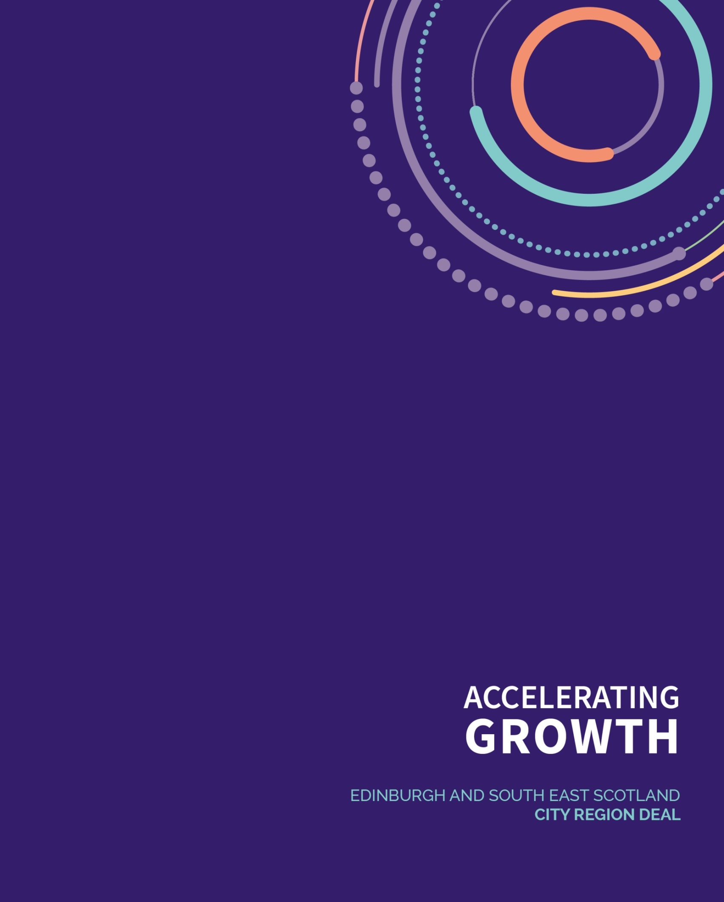

CAPITAL CITY PARTNERSHIP

EDINBURGH AND SOUTH EAST SCOTLAND CITY REGION DEAL: INTENSIVE FAMILY SUPPORT SERVICE

SUMMARY OF CO-PRODUCTION

- INTRODUCTION

This document summarises phase one of the co-production undertaken by Capital City Partnership (CCP) with clients, service providers and stakeholders to support the shape and design of the Intensive Family Support Service (IFSS) under the Edinburgh and South East Scotland City Region Deal (ESESCRD). The IFSS will support families who are experiencing entrenched worklessness and complex, multiple barriers to employment.
This paper details the approach taken in the co-production process and presents the key findings presented to the IFSS Project Board for consideration and fed into the IFSS design and procurement process.
CCP identified current programme models taking a holistic whole family approach across the wider city region, as well as third sector organisations with a depth of experience in working with members of the intended target group. Those organisations were approached and asked to identify service users interested in contributing to the ESESCRD IFSS co-production process.
The co-production had two aims, one was to learn about the experiences of those involved in delivering IFSS and similar programmes, and the other was to gain knowledge of the experiences of those who use IFSS programmes, or similar services.
As each local authority area has specific areas of deprivation or key target locations where the IFSS could make the greatest impact, co-production and design with the local partners who will eventually deliver the service has been a key part of the process. This has contributed to our understanding of the unique circumstances, benefits and challenges of place across the wider city region.

- THE INTENSIVE FAMILY SERVICE CO-PRODUCTION (SERVICE PROVIDER WORKSHOP 1)

In June 2018, CCP held a co-production event aimed at service providers interested in the IFSS. Providing an opportunity for providers to meet, network and potentially form partnerships, the event was held in Edinburgh, and open to all interested parties from across the wider city region.
A total of 40 people attended representing 23 organisations from across four local authorities, and following a presentation from CCP which provided more information on The ESESCRD IFSS, providers were split in to tables and two discussion workshops took place which asked providers to discuss and record what they identified as the needs of the most vulnerable families and the critical elements to success for the IFSS project.
Recommendations from the co-production are highlighted below:
Question: what are the needs of the most vulnerable families?
Recommendations:
Pre-pipeline stages
Holistic service with integration
Mental health important – need resources
Need clear definition of what a family is
Be careful not to just be geographical based as not always where families in need reside

Question: what are the critical elements to success?
Recommendations:
Community based service vital, with linked in support to key agencies
Need to tackle poverty and reduce inequalities
Service should be low key and use other tactics to engage successfully
Community voice need represented
Pilot of projects recommended
Family Plans essential
Framework for assessment and measuring success
Data sharing protocols need to be established early

- THE INTENSIVE FAMILY SERVICE CO-PRODUCTION – CLIENT WORKSHOPS

Making it Work for Families – April 2019

A focus group with the clients of Making it Work for Families (MIWFF) was held in April 2019. Clients of MIWFF reside in Fife, SIMD 1 & 2 areas of Cowdenbeath (including Lochgelly) and Kirkcaldy. Six parents and three young people took part, alongside three members of Fife Gingerbread staff.

The families involved in the workshop live in jobless households and have multiple barriers to progression. Each family has a young person aged 14-19 living at home who is at risk or not achieving a positive destination.

This workshop focused on the clients’ experiences of the MIWFF service asking questions and encouraging discussion around the context of their engagement with MIWFF, the support they receive and environment/s they get support in, as well as impacts on relationships and any changes that have occurred within a personal/family/financial context.

Key points from the co-production workshop with MIWFF parents were:

- The main reason for engagement by parents was to improve life for their children and young people.
- Parents and young people enjoy having separate workers so they each have someone else they can talk to.
- Service users felt ‘stigma’ around joining the service, but through involvement in the service, participants are happy to be involved and act as ‘ambassadors’ helping to support newly engaged parents.
- Flexible and reliable support is key
- Having no time limit on engagement has a positive effect on building relationships
- Relationships with family and schools have improved.

- THE INTENSIVE FAMILY SERVICE CO-PRODUCTION – CLIENT WORKSHOPS
Making it Work for Families – Clued Up, April 2019

A focus group with the young people accessing support in the wider MIWFF service via Clued Up - the youth support organisation involved in the project was held in April 2019.

As previous, the young people involved in MIWFF reside in Fife, SIMD 1 & 2 areas of Cowdenbeath (including Lochgelly) and Kirkcaldy and are affected by substance use. They are supported to achieve their employment potential through the provision of individual tailored programmes of support from Clued Up.

Five young people and one Clued Up worker attended the co-production workshop.

A discussion was held which focused on their experiences as young people in Fife, and their engagement with the MIWFF programme.

Key points from the co-production workshop with MIWFF (Clued Up) young people were:

- Attending the groups and activities allows young people to get out the house and meet new people – parents prefer young people to stay inside due to bad neighbourhoods.
- Young people were keen to engage with Clued Up – but did still worry about stigma, for example, being picked up from home/community in a ‘branded van’.
- Young people felt their families were doing more activities together now, and they were able to help more at home.
- Felt more confident and able to take their minds of home life/any issues they might be experiencing.
- Young people felt that the service had contributed to a more peaceful home environment, and they were more able to talk about difficult situations.

- THE INTENSIVE FAMILY SERVICE CO-PRODUCTION – SERVICE PROVIDERS’ EVENT

A co-production event was held in Glenrothes in April 2019 for stakeholders and third sector partners to inform the programme specification and explore further what a successful service might look like.
A total of 22 people attended, representing 18 organisations from four local authorities. Providers were given an overview of the IFS Commissioning, as well as an overview of the key themes which had come from co-production workshops with service users to date.
18 providers were spilt into three groups and asked to discuss five key questions, which were recorded by the CCP facilitator on each table, as follows:
- Who else should we be talking to in Fife?
- What are the essential elements to good service delivery?
- What infrastructure needs to be in place?
- How will the service engage with the right families?
- How will we know if we are successful?

Recommendations:
- Partnership working and relationship building will be key to the success of any service; involvement should include, but not be limited to: Council Services (Social Work, Early Learning Leads, Criminal Justice, Children and Families, Housing etc), Colleges and schools, DWP, Health services, Youth TAC Teams, Skills Development Scotland, Community Payback Teams, Local Housing Associations, Fife Migrants Forum, Youth Justice, Third Sector Interface (TSI).
- Ensuring the service is holistic, person centred and intergenerational was a key message.
- Flexibility is a crucial element of the service.
- Local delivery with mobile workers and use of local community assets was a clear message.
- Targeted marketing and making use of stories of service users and word of mouth seems to be the key to engagement with the right people.
- Monitoring of both clients and the service throughout the life of the contract was key.
- Finding a way to monitor both hard and soft outcomes was also key.

- THE INTENSIVE FAMILY SERVICE CO-PRODUCTION – CLIENT WORKSHOP

Maximise! – May 2019
A focus group with the clients of Maximise! – a whole family support service, was held in May 2019. Clients of Maximise! have a child/ren who attend a primary or high school within the Liberton cluster in Edinburgh, where the Maximise! project is embedded.

The focus group was facilitated by a member of CCP staff, and the Service Delivery Manager from Children 1st, one of the delivery partners of Maximise!

Seven parents attended the session, along with seven children and one translator. The families who took part are affected by poverty and engage with either one or more of the following components of support from the Maximise! project: family support, advice/income maximisation and employability.
The workshop focused on the parents’ experiences of the Maximise! service, encouraging discussion around the support they have engaged with, how they felt about engaging with the service, what they thought about it being embedded within schools, and whether this had any impact on their relationship with schools, amongst many other areas of discussion.
Key points from the co-production workshop with Maximise! clients were:
- Parents felt no stigma in engaging with the service via the school or self-referral.
- Flexible, reliable support is important to families.
- Having access to a multidisciplinary team through engagement with one service is a positive.
- Advocacy is important - having support to attend meetings and make phone calls and fill in forms
- Most parents felt the connection to the school was positive – and schools could help identify and highlight the service to families who may benefit.
- Self-referral is important too, in case relationships with schools/other statutory partners have already broken down.
- Local support with choice of venues (i.e. home/café/community centre) is important as for some parents, it’s a chance to get out.
- Having someone to talk to, and help with meetings, forms etc takes the pressure of, and allows parents to feel less stressed – impacting positively on their relationships with their children.

6. THE INTENSIVE FAMILY SERVICE CO-PRODUCTION – INFORMAL STRUCTURED DISCUSSION
Home Link – June 2019
An Informal structured discussion with families who use Home Link’s ‘Stay and Play’ service at Goodtrees Neighbour Centre were held in June 2019. Five families, and five children took part in the discussion, all of whom had been attending the group for a substantial length of time.

The discussions were centred around the support families receive from Home Link, and what parents and their children get out of attending the play sessions.

Some of the families who took part were either effected by poverty directly or indirectly. All of the families who took part did not engage in any of Home Link’s more intensive family support service.

The families who took part live in a high SIMD area, and as such, were able to discuss common issues families face in the area around loneliness, housing, lack of local service provision for families with children and safety concerns within the community.

7. THE INTENSIVE FAMILY SERVICE CO-PRODUCTION – CLIENT WORKSHOP
Low Income Families Together (L.I.F.T) – June 2019
A client workshop was held with 12 x service users, 3 x service users’ children and 1 volunteer who attend LIFT’s parent group and creche in the Muirhouse Millennium Centre, in North Edinburgh.
The workshop focussed on the experiences and perspectives of the mums in attendance, all of whom faced various issues relating to poverty including housing,

The importance of positive, welcoming relationships with staff who have ‘been there’ and have ‘lived experience’, with some being former service users, was raised by several parents who felt this helped create connections to the staff.

Parents mentioned the provision of substantial free breakfast food as a welcome aspect of attending the group – having the availability of the creche during the group provided parents with a break, and a chance to have adult conversation with other parents, sharing issues and advice whilst reducing isolation and forming friendships.

8. THE INTENSIVE FAMILY SERVICE CO-PRODUCTION – YOUNG PEOPLES WORKSHOP EVENT
Youth Talk, North West Edinburgh – June 2019
With the view to gathering the perspectives of young people living in North West Edinburgh, CCP were invited to facilitate a table discussion with young people in attendance from various youth groups across North West Edinburgh.
Young people were asked to name the issues they face living in their local areas and present ideas that they felt might improve these issues.
For young people, poverty and the effects of living in poverty were prevalent in their local community. Issues included drug use, anti-social behaviours, under-age drinking, mental health and a feeling that the community was uncared for.
Youths suggested extra youth provision locally, accessible mental health services and access to activities with no costs attached.
9. THE INTENSIVE FAMILY SERVICE CO-PRODUCTION – INFORMAL STRUCTURED DISCUSSION
First Step, East Lothian - June 2019
An informal structured discussion was held with 5 parents, 1 volunteer who is also a service user and 10 children at First Step’s premises in Musselburgh during two separate sessions – one play session and also during a community café session, which provided free cooked lunches to families on a weekly basis during the summer holidays.
The families in attendance of the community café had engaged with several aspects of First Step’s support including respite and counselling. One parent mentioned the importance of ‘flexibility’ in engaging with the service, as she does not worry about repercussions if she isn’t able to attend.
Parents largely felt that the service provided support with parenting, and that the service, alongside the support it provides, signpost to other relevant services in the local area.

10. THE INTENSIVE FAMILY SERVICE CO-PRODUCTION – INFORMAL STRUCTURED DISCUSSIONS
Sure Start, Midlothian, September 2019
Informal structured discussions were held within three of Sure Start’s Family Learning Centres – Penicuik, Woodburn and Mount Esk (Bonnyrigg).
Overall, eight parents with six children took part in the discussions, with focus on their lives and experience of engaging with the Sure Start service. Several parents were in attendance to play groups for their children, while others were establishing skills by engaging in creche worker courses and volunteering to help prepare for fundraising events whilst their children played.
The family learning centres provide parenting support and opportunities for learning new skills, such as cooking and employability.
One of the biggest issues that was raised included travel across and around Midlothian – connections are poor and travel distances can be long. The closest inexpensive food shop is a bus journey away, adding the extra cost of travel to the shopping bill as well as a struggle to transport food items home.
It is also a bus journey to the nearest council building and jobcentre which adds difficulty for families who are living on a very tight budget.
Significantly, families felt that the provision of travel and/or costs to and from the college course they attended were essential to their taking part and receiving their qualifications.
One lone parent who works part time with two young children felt that in emergencies, where she may need to travel to a hospital with her child, it was a choice between paying full rent or paying for bus travel.
This parent has been affected by the benefit cap, and as a result, relies on a fluctuating Discretionary House Payment (DHP) to make up part of the higher cost rent for the temporary accommodation the family occupy. The parent is unable to know whether the DHP will cover housing costs, and this causes constant worry.
11. THE INTENSIVE FAMILY SERVICE CO-PRODUCTION – YOUTH WORKSHOP
Midlothian Youth Platform - September 2019
A workshop was held with four young people from different areas of Midlothian around poverty as they have experienced it. The group were asked to work together to think of issues associated with poverty in the area and then prioritize these.
The group shared their own experiences of homelessness, housing issues, teenage pregnancy and being a single mum. The group felt that after the age of 18 support in Midlothian dropped off and whilst several of the young people worked, they felt they missed out on a lot because of the constraints of their budgets.
The group identified that prevention from involvement with approachable trusted services / people earlier in their lives, before any crisis develops, would be a solution to some of the issues they now experience.
Information collated from all co-production has been used to inform the specification for phase one of the IFSS in Fife, which will be launched in May 2019. Further co-production workshops and one to one co-production sessions (both face to face and via telephone) will take place across the wider city region throughout Summer 2019, with findings being collated to inform the specifications for phase 2 of the IFSS in the other areas the ESESCD.

Five themes have been identified from the co-production undertaken to date:

Theme 1: Delivery

Stakeholders gave a clear message that any commissioned service embraced local delivery with mobile workers and accessible, flexible support. Use of local community assets was highlighted as best practice.

Theme 2: Integration
Partnership working and relationship building will be key to the success of any service. The provider should consider a stakeholder engagement plan to ensure joined up delivery.

Theme 3: Empowerment

Providing families with the tools and skills to enable long term, sustainable change beyond the end of the service.

Theme 4: Reducing Inequality
Ensuring the service is holistic, person centred and intergenerational was a key message.
Theme 5: Engagement

Targeted marketing and making use of stories of service users and word of mouth seems to be the key to engagement with the right people. Stakeholders agreed that monitoring soft outcomes and indicators should be on a par with outcomes reporting.

