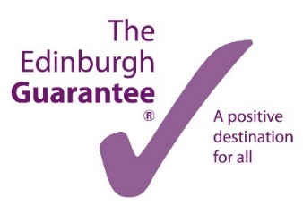

Recruiting in October 2020 for Early Years Apprentices
The City of Edinburgh Council will be recruiting up to 10 Modern Apprentices to join our Early Years team, working in Council Nurseries and Early Years Centres throughout the city.
This is an exciting opportunity and a chance to:
- earn a salary while working towards a recognised accredited SVQ/Modern Apprenticeship qualification helping you move into a career in Early Years
- develop new skills while making a valuable contribution to the service.
Eligibility, Qualifications and Qualities:
- Left school within the last 3 years (or aged up to 29 years if you are care experienced or have a disability)
- Educated to National 5 level (see employee specification in job advert)
- Passionate about working with children
- Keen to learn and gain a qualification.
Look out for vacancies being advertised on the following websites from 5 – 16 October:
MyJobScotland www.myjobscotland.gov.uk
The Edinburgh Guarantee www.edinburghguarantee.org
Apprenticeships.Scot https://www.apprenticeships.scot/

Don’t hesitate to get in touch for further information by emailing:
apprenticeships@edinburgh.gov.uk

d

