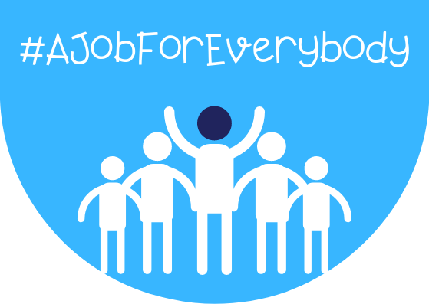

PARTNERS CAMPAIGN PACK
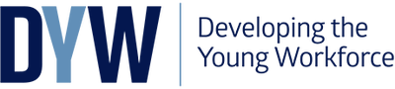
Contents page

Page 1 - About DYW Equalities Campaign
Page 2 – 4 - #Ajobforeverybody
Page 5 - #Myskillsmakeme
Page 6 – Aims
Page 7-8 – Get Involved
Page 9 –11 - Promotion

About DYW Equalities Campaign
(#ajobforeverybody featuring #myskillsmakeme)

Developing the Young Workforce (DYW) 21 regional groups are preparing to launch an equalities focused week of events and social media campaign across Scotland on w/c Monday 16th November 2020. The week campaign will be aimed at employers, parents and young people that promotes, illustrates and celebrates diversity and inclusion in the workplace.

Building on last year’s #ajobforeverybody campaign with another week of highlights we will be introducing a new feature as part of the week - #myskillsmakeme.
As a DYW Partner we would value your support to raise awareness of the equalities focused week. This digital toolkit can be used across your marketing and communication channels to help promote the DYW Equalities Campaign, and your involvement within it.

Page 1
#ajobforeverybody

On w/c 16th November we will be using #ajobforeverybody to share stories and experiences which prove that everyone can contribute and be of benefit to employers.

Aimed at employers, parents and young people #ajobforeverybody intends to promote, illustrate and celebrate diversity and inclusion in the workplace as well as to encourage businesses and organisations to realise that there are many organisations in the region around them willing to meet with them and advise and support them in recruiting.

The week will also see a series of events arranged by DYW Dumfries & Galloway including a Live Event ‘Strengthening Diversity through Inclusion’ with 3 In Consulting and several webisodes from the DWP featuring Disability Confident and the return of 'Play Your Cards Right!' with Sue Livermore, (from Dumfries & Galloway College) which was extremely well received last year.

Page 2
Below you will see an overview of the series of events/webisodes taking place during the week:

LIVE EVENT - Wednesday 18th November, 12.00
‘Strengthening Diversity through Inclusion’ with 3 In Consulting, presented by Paul Skovron

During this live event Paul will be talking about the pitfalls and advantages of creating a diverse workforce. The session will cover:

- The importance of equality in the workplace and the legal requirements on organisations to comply with the Equality Act
- The impact of discrimination and bias in the workplace
- Explain the concepts of diversity and inclusion
- The opportunities and advantages of creating an empowered diverse workforce
- How an engaged diverse workforce transforms organisations
- How an inclusive organisation can reap tangible benefits through the diversity

The information above can be used to promote the live event out to your employer contacts. This can be promoted out via email, website and your social media channels. Booking for the event can be made via the Eventbrite link: https://www.eventbrite.co.uk/e/strengthening-diversity-through-inclusion-tickets-124662854955. Details on where it will be premiering will be circulated to regional groups ASAP and also following registration.

Page 3
Webisodes

All of the below webisodes will sit on DYW Dumfries and Galloway’s YouTube channel in the #ajobforeverybody playlist. The webisodes will be posted from DYW Scot’s twitter page as well as DYW Dumfries and Galloway’s social media channels on the specific date allocated below. We would encourage partners to retweet/share the webisodes from these social accounts or they can create their own posts for the webisodes to go out on the dates below using the link to the webisodes https://www.youtube.com/watch?v=0e24rfTZ2CQ&list=PLSiZbiC5wP8D4HolMKQsquLEX2fa2bjMz.

‘Play Your Cards Right’ with Sue Livermore

A series of 5 x 5 minute webisodes highlighting actual advertisements published in various magazines/papers from businesses and organisations.

Monday 16th November - Webisode 1: Faith
Tuesday 17th November - Webisode 2: Husband and wife..?
Wednesday 18th November - Webisode 3: Robust
Thursday 19th November - Webisode 4: On Show
Friday 20th November - Webisode 5: Sick

Disability Confident

A series of 3x5 minute introductions to the Disability Confident programme from Department of Work and Pensions.

Tuesday 17th November - Webisode 1: Welcome to Disability Confident
Wednesday 18th November - Webisode 2: What do you need to provide?
Thursday 19th November - Webisode 3: Progress with Disability Confident Page 4
#Myskillsmakeme

This year we are also introducing a new feature as part of the week - #myskillsmakeme

Similar to #NoWrongPath we have produced a simple visual template that people from all backgrounds will be able to download and use to highlight their skills and encourages them to think aspirationally about their career pathways.

This element is also open to all ages so that adults who have had to struggle with society perceptions when in work can also act as role models to the next generation. This feature will also be sent to schools with the hope of including pupils in the highlights.

By looking beyond the barrier or condition we want to show young people and individuals that by working on their skills, attitude and approach to life they have it within their control to affect their outcome and we want employers to see the emerging talent of our young people based on the skills they are developing.

Page 5
Aims
- To illustrate and celebrate diversity and inclusion in the workplace
- To challenge stereotypes
- To provide real examples that illustrate diversity and inclusive practice in the workplace
- To highlight regional partners who will support businesses/organisations in understanding diversity and inclusion
- To illustrate the skills people, bring to the workplace

Page 6
Get involved

There are a number of ways you can support equalities focused week, this pack contains all the information and resources you need to get started.
Support your employer network
Reach out to people in your area and encourage them to get involved with the promotional week.

Spread the word to employers/young people/adults
Using the resources provided in this toolkit, use your communications channels to promote the equalities focused week to employers, young people and adults. This could be by posting on social media, website, news page etc. to create a powerful campaign.

Engage young people/adults/schools in your local area
Using the activity resources in this toolkit partners should encourage young people, adults and schools in their local area to get involved in the campaign also by asking them to take part in the #myskillsmakeme activity provided and posting out w/c 16th November.

We have created two #myskillsmakeme activities one aimed at young people and one aimed at adults. These templates can be printed off and completed.

Page 7

Young People Activity
This involves asking young people to write down their skills and what they want to do using the template provided.
Adult Activity
This involves asking adults to write down their skills and any barriers that they have faced.
You should encourage anyone taking part in the campaign to post their completed activity on social media w/c 16th November tagging their local DYW group and using the hashtag #myskillsmakeme and #ajobforeverybody. If for any reason they can’t post on social media, they should send their completed template to their local group or for you to post on their behalf.

Page 8
Promotion
As a partner of DYW we would encourage you to spread the word about the qualities focused week.
- Sharing Information about #ajobforeverybody and #myskillsmakeme activities on your website encouraging people to get involved
- Promoting out #ajobforeverybody and #myskillsmakeme activities on your social media channels encouraging people to get involved
- Connecting with other DYW partner organisations across all channels and share their messages
- Connecting with other DYW groups and share their messages across your social media platforms on

Page 9
Social Media
In the run up to the equalities focused week w/c 16th November partners should create posts promoting the events and activities encouraging young people, businesses and schools to get involved.
Partners should be using the hashtags #ajobforeverybody and #myskillsmakeme when promoting out posts across their digital channels.

Page 10

Graphics and Logos

You will find attached all social media graphics and resources needed for the campaign.

Partners can use the graphics and add DYW Scot branded logo and any other details to the graphics.

If you need any graphics in an alternative format or size, or need any further assistance then please contact danielle@dywayrshire.com.

Page 11

